# Car Rental System

# Deliverable#2

* Ahmed Adel 22-101252
* Ahmed Badr 22-101101
* Amr Azazy 22-101237
* Hazem Amer 22-101105

# Tabular Representation

|  |  |  |
| --- | --- | --- |
| NOUN | NOTES ON NOUN | decision |
| customer | The person who rents the car and deals with the system | i |
| Account | The profile that stores customer personal info | i |
| Reservation | The booking made by customer for a vehicle, which include information about the car and period rented | i |
| Vehicle | The car being rented | i |
| Rental Quote | The estimated cost for renting the vehicle | i |
| Service Fees | Additional charges | e |
| Rental Period | The duration for which the vehicle is reserved | e |
| Payment | The physical transaction that occurs at the office when the customer pays for the rental | i |
| Vehicle Pickup | customer collects the vehicle from the rental office | e |
| Identification | The customer's identification verified at the time of vehicle pickup | e |
| Vehicle Condition | The condition of the vehicle at the time of pickup and return | e |
| Mileage | The distance traveled by the vehicle during the rental period | e |
| Fuel Level | The fuel level of the vehicle when returned | e |
| Late Charges | Charges for returning the vehicle after the agreed-upon time | e |
| Damage Charges | Charges for any damage to the vehicle during the rental period | e |
| Final Receipt | The document issued after the vehicle return that summarizes the charges | e |
| Fleet | The collection of vehicles available | i |
| Fleet Management System | The system that manages the availability | e |
| Maintenance Schedule | The plan for routine maintenance | e |
| Maintenance Log | The record of completed maintenance tasks for each vehicle | i |
| Repair | Maintenance work done on a vehicle to fix damage or mechanical issues | e |
| Service History | The record of all repairs and maintenance performed on each vehicle | e |
| Vehicle Availability | The status of whether a vehicle is available for rental | e |
| Customer Profile | A record of a customer's personal details | e |
| Rental History | A record of past rentals made by the customer | e |
| Feedback | Customer feedback related to their rental experience | e |
| Loyalty Points | Points awarded to customers based on rental activity | i |
| Promotion | Discounts or special offers provided to customers | e |
| Recommendation | Suggestions made to customers based on their rental history | e |
| Additional Service | Extra services requested by the customer, such as GPS devices, child seats, or roadside assistance | e |
| Service Availability | The availability of additional services at the time of vehicle pickup | e |
| Service Fee | The additional charge for providing a service | e |
| Admin Dashboard | The interface for Rent-a-Ride administrators to view and manage system data and generate reports | i |
| Vehicle Utilization Report | A report that tracks the usage of vehicles | e |
| Customer Trends Report | A report that tracks customer behaviors | e |
| Revenue Report | A financial report that tracks income from rentals | e |
| Feedback Report | A summary of customer feedback | e |

# UML Diagram

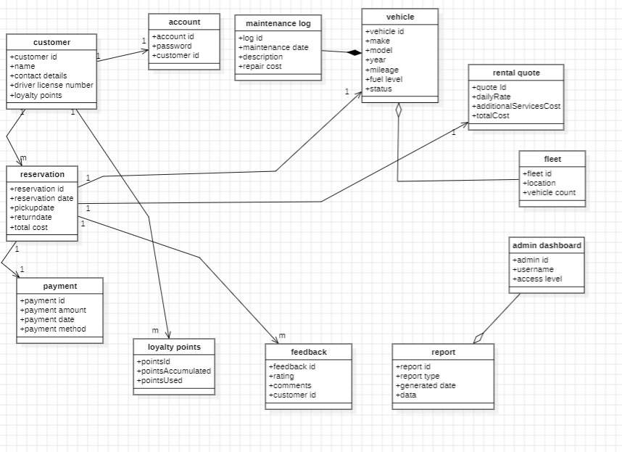

# Use Cases and CRUD Technique

CRUD Verification for the use cases

|  |  |  |
| --- | --- | --- |
| **Domain Class** | **CRUD Operation** | **Use Case** |
| Customer | C | |  | | --- | | Customer Account Creation |  |  | | --- | |  | |
|  | R | Customer Reservation History Access, Loyalty Program Tracking |
|  | U | Customer Account Modification |
|  | D | Account deletion by admin or on request |
|  |  |  |
| Vehicle | C | Vehicle Fleet Registration |
|  | R | Vehicle Search and Reservation, Reporting |
|  | U | Update status during return, maintenance |
|  | D | Retire a vehicle from fleet |
|  |  |  |
| Reservation | C | Vehicle Search and Reservation |
|  | R | Customer Reservation History Access, Pickup/Return Verification |
|  | U | Modify or extend reservation details |
|  | D | Cancel reservation |
|  |  |  |
| Feedback | C | Feedback Submission |
|  | R | Reporting and Analytics, Admin Review |
|  | U | Allow minor edits if enabled |
|  | D | Admin deletes inappropriate feedback |
|  |  |  |
| Loyalty Points | C | Loyalty Program Tracking |
|  | R | View loyalty points, Reporting and Analytics |
|  | U | Adjust points |
|  | D | Clear points if account is closed |

CRUD Analysis Result: Use Case / Domain Class Matrix

|  |  |  |  |  |  |
| --- | --- | --- | --- | --- | --- |
| **Use Case vs. Domain Class** | **Customer** | **Vehicle** | **Reservation** | **Feedback** | **Loyalty Points** |
| Customer Account Creation | C/R/U |  |  |  |  |
| Vehicle Search and Reservation | R | |  | | --- | | R |  |  | | --- | |  | | C |  |  |
| Vehicle Pickup and Identity Verification | R | R | R |  |  |
| Vehicle Return and Condition Logging | R | U | R |  |  |
| Feedback Submission | R |  |  | C |  |
| Loyalty Program Tracking | R |  |  |  | C/R/U |
| Reservation History Access | R/U |  | R |  | R |
| Reporting and Analytics Generation | R | R | R | R | R |